Intelligent Anomaly Detection and Resolution in IBM Db2 Genius Hub

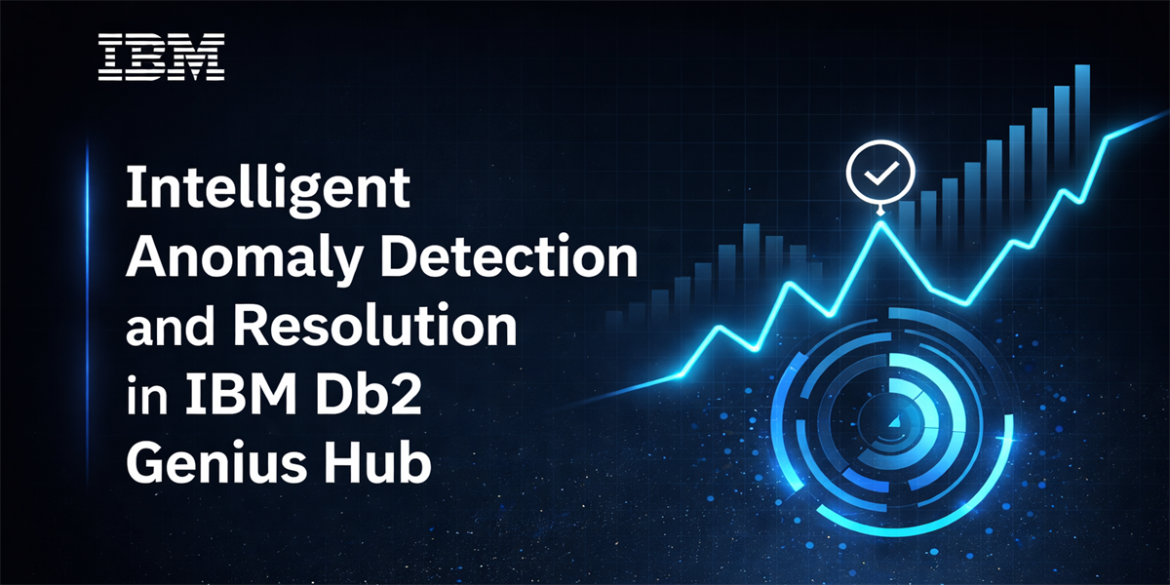

Introduction
IBM Db2 Genius Hub represents a significant advancement in database management, delivering an AI-powered experience that transforms Db2 towards autonomous database through its agentic capabilities. The Db2 Genius Hub offers numerous innovative features, this article particularly focuses on the Anomaly Detection and Resolution capability, examining its technical implementation and practical benefits for database administrators.
[Db2 Genius Hub: Anomaly Detection Video] https://youtu.be/jfFQGuSJqpM?si=WHjXrzYEaMOvwAd7

Challenge with traditional database monitoring
Traditional database monitoring approaches require administrators to manually configure alert thresholds based on performance statistics. Conventional data management consoles provide mechanisms to create standard or custom alerts that trigger when specific conditions are met, such as:
- CPU utilization spikes
- Temporary tablespace over-utilization
- Memory consumption anomalies
- Log space exhaustion
- Performance degradation patterns
The fundamental limitation of this approach is that it requires deep domain expertise. Database administrators must possess comprehensive knowledge of expected versus problematic metric values across different environments (production, test, development) to configure meaningful alerts. This prerequisite creates several challenges:
- Knowledge dependency: Alert configuration quality directly correlates with the administrator's experience and understanding of the specific workload characteristics
- Static thresholds: Fixed threshold values cannot adapt to changing workload patterns or seasonal variations
- Configuration overhead: Each metric requires careful analysis and threshold determination

Autonomous approach: AI-Powered anomaly detection
Db2 Genius Hub fundamentally reimagines this paradigm. Instead of requiring administrators to define thresholds and configure traditional alerts, the system employs Machine Learning(ML) algorithms to:
- Learn normal behaviour patterns: Auto learns behaviour/patterns: The system automatically learns and establishes baseline behaviour for each monitored metric from your different database workload. This ensures that the ML model learns your database usage pattern live and accordingly detects the possible anomalies.
- Detect abnormal changes: Advanced algorithms identify deviations from established patterns without predefined thresholds.
- Provide intelligent alerts: Notifications include context, confidence levels, and actionable insights.
This approach eliminates the need for manual threshold configuration while providing more accurate and contextually relevant alerts.

Supported metrics for anomaly detection
The anomaly detection capability currently supports the following key performance indicators:
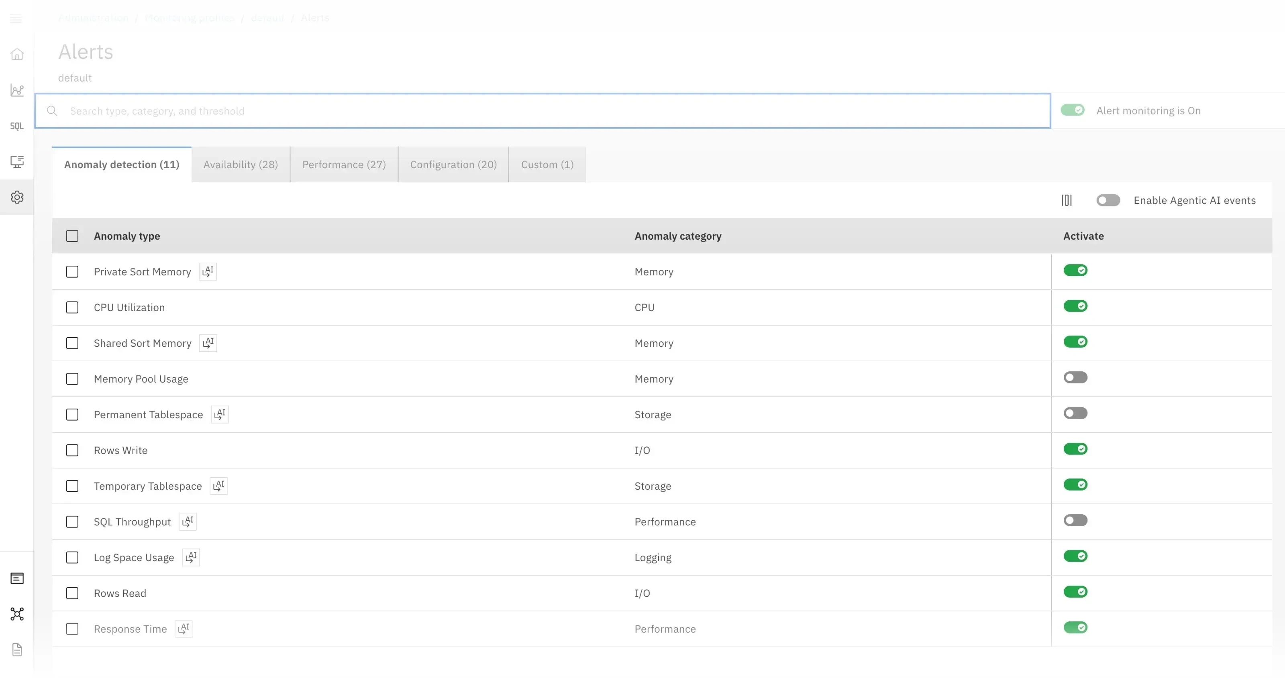

Resource utilization metrics
- CPU utilization: Processor consumption patterns
- Memory pool usage: Database memory allocation and utilization
- Private sort memory: Individual query sort memory consumption
- Shared sort memory: Shared sort heap utilization

Storage metrics
- Permanent tablespace: Persistent storage utilization
- Temporary tablespace: Temporary storage consumption
- Log space usage: Transaction log space utilization

Performance metrics
- SQL throughput: Query execution rate
- Response time: Query response latency
- Rows read: Data retrieval volume
- Rows write: Data modification volume
These metrics are accessible through the administration interface at: Administration → Monitoring Profiles → Select Profile → Alerts
Anomaly alerts operate at the profile level, applying consistently across all database connections associated with the same monitoring profile. Additional metrics and enhanced user controls are planned for future releases.

Agentic AI integration: Detection to resolution
In the "Anomaly detection" tab of the "Alerts" page, certain metrics display an "AI" indicator, signifying integration with the platform's agentic capabilities.

Enabling Agentic AI events
The monitoring profile configuration includes an option to enable or disable Agentic AI Events (by default its disabled). When activated, the system extends beyond simple anomaly detection to provide intelligent analysis and remediation suggestions powered by Agentic AI capabilities of Genius Hub.

Agentic workflow
When an anomaly is detected with Agentic AI Events enabled, the following workflow is initiated:
- Alert generation: The system generates a notification in the Genius Hub notification center.
- Multi-channel notification: Alerts are distributed through configured channels (email, SNMP) based on your notification preferences.
- Agentic analysis: The AI assistant automatically initiates an investigation of the incident right at the time of occurrence of such events/anomalies and keeps the analysis ready to be consumed by users.
- Solution generation: The agentic service analyzes the anomaly context and generates potential solutions and recommendations.
- Interactive investigation: Users can access detailed analysis through the "Investigate Anomaly" button.

Detailed anomaly information
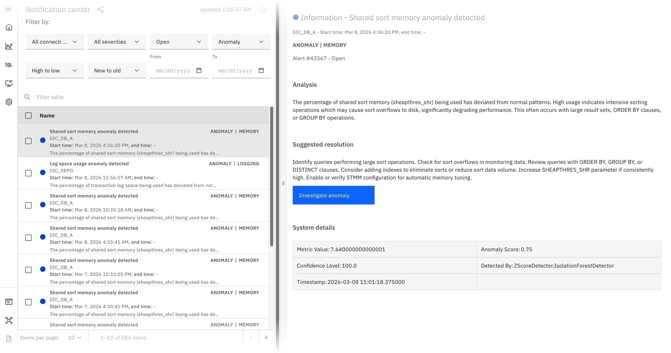

Each anomaly alert provides comprehensive diagnostic information:

- Metric value: The specific value that triggered the anomaly detection
- Confidence level: The statistical confidence of the detection model
- Detection model: The ML algorithm used for anomaly identification
- Anomaly score: Quantitative measure of deviation from normal behavior
- Detection timestamp: Precise time of anomaly occurrence

When users click "Investigate Anomaly", they are directed to an AI chat interface where analysis and recommendations generated by the Agentic AI Assistant are available to be consumed/actioned by users.
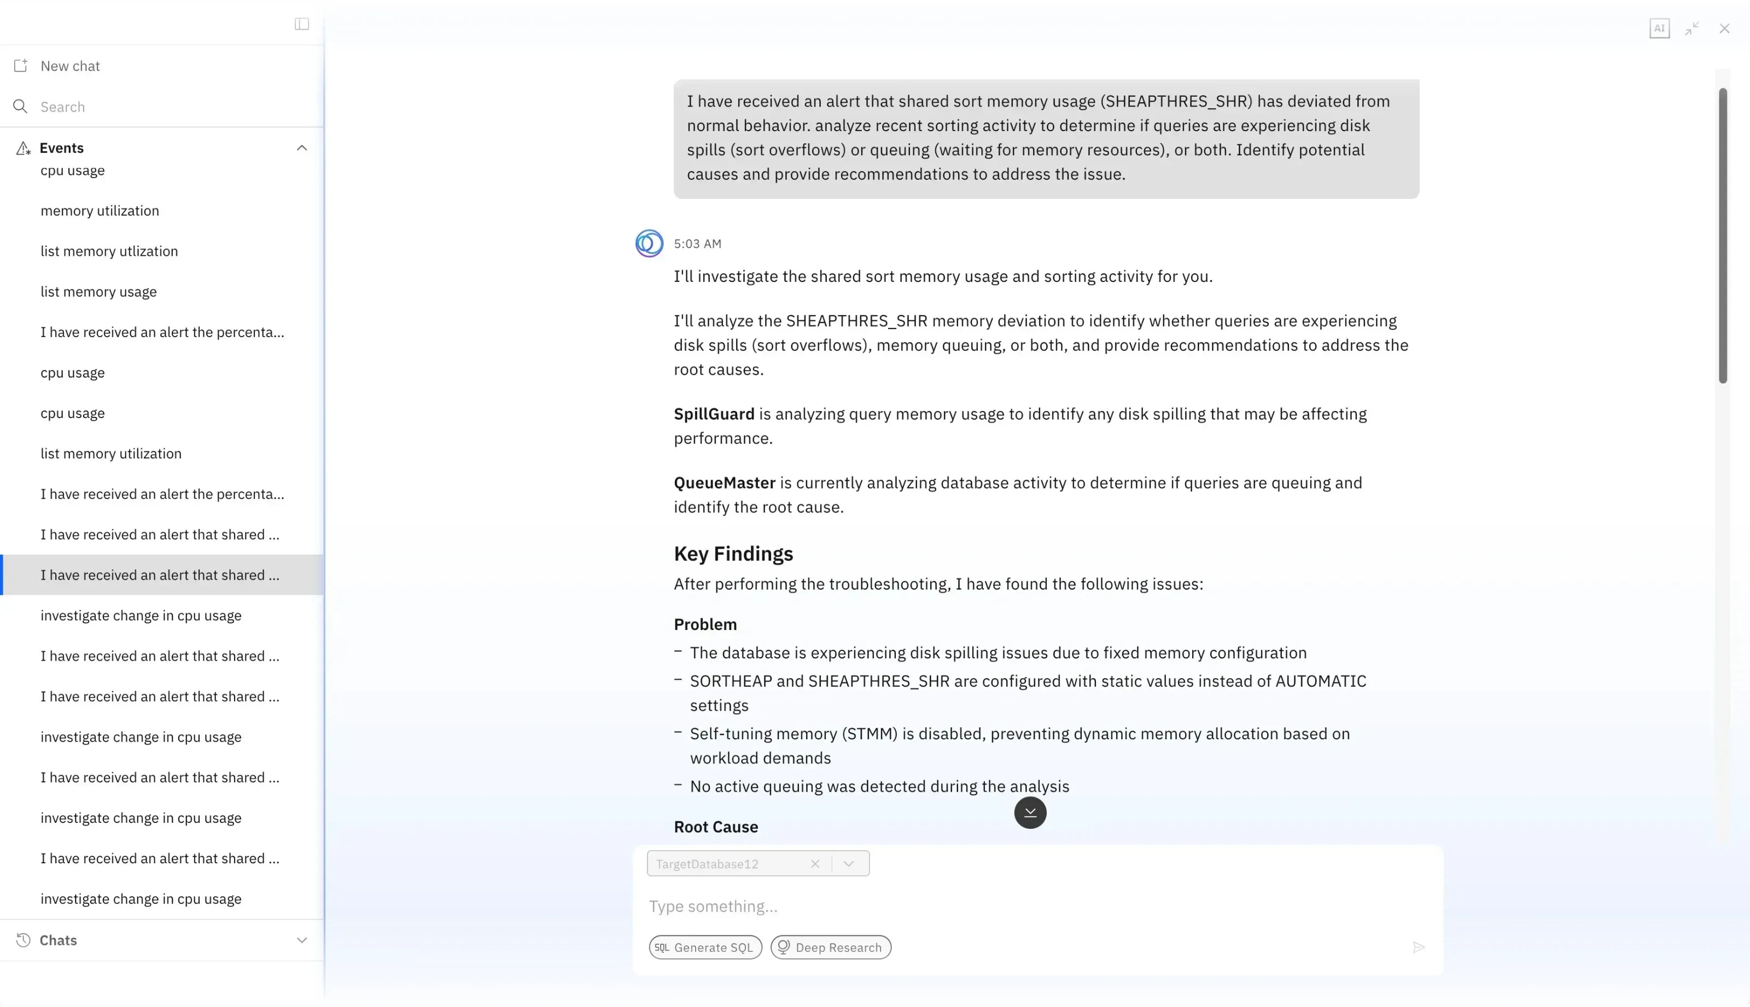

Technical Architecture and Implementation

Data collection and training
The anomaly detection engine leverages the same KPI metrics data collected by Db2 Genius Hub based on monitoring profile configurations. The system initiates structured initialization and operation cycle as follows:
- Initial setup: Upon installation, the anomaly detection engine remains dormant until explicitly enabled. User can go and enable each metric for Anomaly detection by going into the Alerts page.
- Data accumulation: The system requires sufficient historical data before initiating detection capabilities.
- Initial training: Once adequate data is collected, the engine performs initial model training.
- Continuous detection: After training completion, the system evaluates metrics at each collection interval.

Detection algorithms
The anomaly detection engine employs an ensemble approach using multiple algorithms:

Z-Score detector
Statistical method that identifies anomalies based on standard deviation from the mean. This algorithm is effective for detecting sudden spikes or drops in metric values.

Isolation Forest detector
Machine learning algorithm that isolates anomalies by randomly selecting features and split values. This method excels at identifying outliers in high-dimensional data.

Ensemble voting mechanism
The system implements a consensus-based approach where both algorithms must classify a metric value as anomalous before generating an alert. This dual-validation mechanism significantly reduces false positives while maintaining high detection accuracy.

Alert rate limiting
To prevent alert fatigue and notification spam, the system implements intelligent rate limiting. This mechanism restricts the frequency of anomaly alerts for the same metric, ensuring that administrators receive meaningful notifications without being overwhelmed by redundant alerts.

Continuous learning and model retraining
The anomaly detection system is not static. It implements continuous learning through periodic model retraining:
- Retraining schedule: Models are retrained weekly by default using the most recent data
- Adaptive baselines: New training cycles incorporate recent patterns, allowing the system to adapt to workload evolution
- Seasonal pattern recognition: Regular retraining enables the system to learn and accommodate seasonal variations in database activity
After each retraining cycle, subsequent anomaly detection operates on the updated models, ensuring that the system remains accurate as workload characteristics evolve.

Configuration and Tuning
While the anomaly detection system operates autonomously, certain global parameters can be configured in the dswebserver_override.properties file located under Genius Hub installation folder to fine-tune engine behavior:

Available configuration parameters
# Alert cool down period in hours
anomaly.cooldown.time=6
Purpose: Controls the minimum time interval between alerts for the same metric
Unit: Hours
Function: Prevents alert spam by enforcing a cooldown period after an anomaly is detected
Default value: 6 hours

# Standard deviation threshold in percentage
anomaly.stddev.threshold=60
Purpose: Defines the deviation threshold for triggering new alerts
Unit: Percentage
Function: If a metric value deviates beyond 60% of the last anomaly value, a new alert is triggered. This parameter balances sensitivity with noise reduction.
Default value: 60 %

# Model retraining interval in days
anomaly.retrain.age=30
Purpose: Sets the interval for automatic model retraining
Unit: Days
Function: Determines how frequently the system retrains its detection models with new data. This background process ensures models remain current with evolving workload patterns and can capture seasonal variations.
Default: 30 Days

Benefits and Use cases

Reduced administrative overhead
Eliminates the need for manual threshold configuration and maintenance, allowing administrators to focus on strategic initiatives rather than alert tuning.

Improved detection accuracy
Machine learning algorithms adapt to workload patterns, providing more accurate anomaly detection than static thresholds while reducing false positives.

Faster problem resolution
Integration with Agentic AI provides immediate analysis and remediation suggestions, significantly reducing mean time to resolution (MTTR).

Proactive database management
The system identifies potential issues before they impact production workloads, enabling proactive rather than reactive database administration.

Knowledge democratization
Reduces the expertise barrier for effective database monitoring, making advanced anomaly detection accessible to administrators with varying experience levels.

Conclusion
The Anomaly Detection and Resolution capability in IBM Db2 Genius Hub represents a fundamental shift in database monitoring and alerting philosophy. By combining machine learning-based anomaly detection with agentic AI-powered analysis and remediation, the platform transforms database administration from a reactive, expertise-dependent discipline into a proactive, AI-assisted practice.
As the system continues to evolve with additional supported metrics and enhanced capabilities, it promises to further reduce the operational burden on database administrators while improving the reliability and performance of Db2 database environments.

About the Authors
- Jobin J is a Software Developer at IBM ISL, Kochi, India. He is currently working on IBM Db2 Management Console–related projects, with active involvement in Db2 Genius Hub, particularly the Db2 Anomaly Service. Previously, he worked on IIAS and the DMC console, focusing extensively on customer issues, development, and application performance–related enhancements.
- Sheshnarayan(Shesh) Agrawal is STSM (Senior Technical Staff Member) at IBM. Shesh is Chief Architect for Db2 Genius Hub and Db2 AI tools. Shesh has over 2 decades of experience on database tools and APIs. Shesh has 7 patents primarily in the database and tools area.

